Title
CR2395
MDM/Central DB
Business Requirements
Document

Version:  Last Revision Date:  Print Date: | 1.0

Document Statistics

Document Identification | The following is current information about the document: (Maintain all relevant section)
 |  | Object ID | CR2395
 |  | Title | Additional Central DB fields
 |  | Version | 1.0
 |  | Creation Date | 08/16/2013
 |  | Author | Deborah Stonier
 |  | Application | SAP
 |  | Development Type
 |  | Document Status

Revision History | The following is a history log of revisions to the document:
 |  | Version | Author Of Revision | Creation Date | Comments
 |  | 1.0 | Deborah Stonier |  | Initial Version

Table of Contents

1 Purpose of a Functional Specification 4
2 Benefits of a Comprehensive Functional Specification 4
3 General Requirements 4
3.1 Business Driver 4
3.2 Current Functionality 4
3.3 Desired Functionality 4
3.4 Assumptions 5
3.5 Constraints 5
3.6 Performance Criteria 5
3.7 Applications Affected 5
4 Required Data 5
4.1 Input Data 6
4.2 Output Data 6
4.3 Data Mapping 6
4.4 Legacy File Details 6
5 Form / Report Design 7
5.1 General 7
5.2 Selection Criteria 7
5.3 Output Layout 7
6 Conversion / Interface Design 8
6.1 General 8
6.2 Dependencies 8
6.3 Scheduling Considerations 8
7 Enhancement / Modification Design 8
7.1 General 8
7.2 Required Screens 9
7.3 Screen Layouts 9
8 Additional Information 9
8.1 Test Plan 9
8.2 Backup / Recovery 9
8.3 Security Profile & Authorization 9
8.4 Audit / Control 10
9 Sign Off 10
9.1 Date of Functional Specification Review 10
9.2 Lead Sign off 10

Purpose of a Functional Specification

The purpose of a functional specification is to clearly articulate the business requirement for functionality and FRICE objects for a specific business process or function. It is used to develop technical specifications for all development work associated with the business requirement. Functional specifications also form the basis for test scrip scenarios and training materials. Functional specifications are written by BTI team resources with input from the business. The business will validate and sign-off on functional specifications. A functional Specification does not describe the design of an application nor its interface with another application.

Benefits of a Comprehensive Functional Specification

- Easier for development as requirements are articulated.
- The FS will be approved by the business, to give confidence that the development is on the right track.
- Easy to interpret, minimise communication problems and misunderstanding.
- The document is written in a human language, it is easier to communicate design ideas and change a few paragraphs rather than deciphering a massive amount of code.
- Easier to find alternative solutions.
- Easier to allocate resources against a FS.
- Introduces an element of discipline in the development process.
- FS can be used for validation purposes, i.e. for checking whether the development really implements the features described in the FS.
- Form the basis for testing, verification and training.

General Requirements

Business Driver

Additional fields are needed to support the MDM project.

Current Functionality

To support the MDM project some additional fields are needed in the Central DB. Also, in the central DB the telephone and extension are combined, this field needs to be two separate fields. Some of the other fields are not in the Central DB and must be added.

Desired Functionality

SAP Work:

In the SAP Customer IDOC the telephone and extension are combined and on the IDOC as one field. The single field needs to be broken up into two fields on the IDOC.

**Contact Information:
- Telephone – make single field in IDOC
- Extension – make single field in IDOC
- Add Sequence number to IDOC – ADTEL-CONSNUMBER

- E-mail: Add sequence number to IDOC: ADTEL-CONSNUMBER

**Add the following fields to IDOC
- Express Station (KNA1-BAHNE)
- Regional Market (KNA1-RPM)

**Add the following fields to IDOC
- Country Add to customer IDOC
- Country code; Add country code to the decode table and assign the associated country code to the country. Example, the country of US needs, the country code of +1 assigned.

So, example, include the country of US and the country code of +1 in the customer phone contacts table.
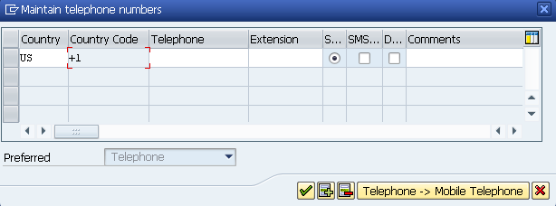

Decode Table:
Add the Decode Values to Decode IDOC and Central DB for the following MDM Required Fields.
- Country and Country calling code See screen print above for country code (+1) add
- Shipping service level code KNVV-ZZSLEVEL
- Shipping service description KNVV-ZZSLEVEL description

***Not done yet as we have questions out to the MDM team
- CLASS and Characteristic Description and All possible values for the following fields:
- Qualification type classification
- Licensedin type Classification
- Membership type
- Pertinent course type
Example: for the below classification (see screen print below) would include:
Class is LicensedIn
Description is LICENSED IN/MAJOR FIELD OF STUDY
Include all the possible values such as
LI_Accounting
LI_Business
LI_Career Counseling
Etc….

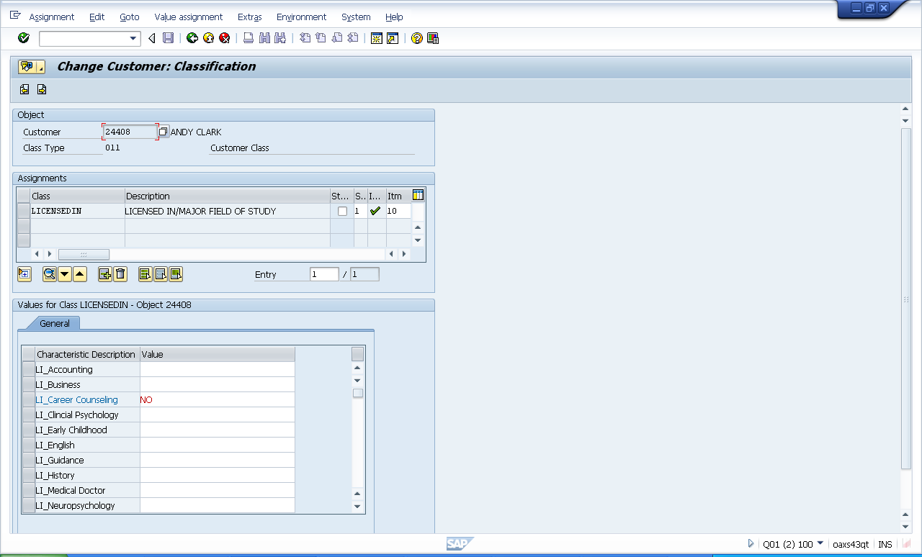

Tibco Work
- Add extension to the phone information in the customer contact table
- Add sequence number to the customer phone contact table
- Add sequence number to customer contact e-mail table
- Add Express Station to the customer table
- Add Regional Market to the customer table
- Add Country to the customer contact table
- Add country code to the decode table and assign to associated country
- Ensure the new decode values, list above, are populated in the decode table in Central DB and pubsub.
customerType.getCHILDREN().getValue().getE1KNA1M().getValue().getItem().getCHILDREN().getValue().getE1KNA11().getValue().getItem().getCHILDREN().getValue().getZ1TELEP().getValue().getItem().get(0).getFIELDS().getValue().getTELEXTENS()
customerType.getCHILDREN().getValue().getE1KNA1M().getValue().getItem().getCHILDREN().getValue().getE1KNA11().getValue().getItem().getCHILDREN().getValue().getZ1EMAIL().getValue().getItem().get(0).getFIELDS().getValue().get
e1kna1m4x.getBAHNE();
e1kna1m4x.getRPMKR();

Assumptions
State assumptions made that would impact development, test, and/or implementation of this solution.

Constraints

Performance Criteria
Identify any system performance criteria that must be met.

Applications Affected
List of the application areas being changed or affected by this design.
SAP

SAP Module | Impact/Change Description

NON-SAP System | Impact/Change Description

Required Data

Input Data
Describe the data required to support the development. Where possible include input field definition (Structure or Table Name, Field Name, Field Description, Format, Values). Include this information when there is no data mapping or corresponding legacy data file.

From System Name | Structure or Table Name | Structure or Table Location |  | Expected Volume
Field Name | Field Description |  | Format | Values

Output Data
Describe the data created from this development. Where possible, include output field definition (Structure or Table Name, Field Name, Field Description, Format, Values). Include this information when there is no data mapping or corresponding legacy data file.

To System Name | Structure or Table Name | Structure or Table Location |  | Expected Volume
Field Name | Field Description |  | Format | Values

Data Mapping
SAP fields are mapped to non-SAP (legacy) fields in the field map. The required field map rules should be described in the field map to ensure the appropriate mapping are done. This information is required for conversions.

N/A

Legacy File Details
Include details about all legacy data files used for input or output. This information is pertinent for conversions and file-based interfaces. For each one, specify the following information wherever applicable.

File Location and Name:
Logical File Name:
Variants:
Legacy File Description:
Sort Requirements:

Legacy File Layout:
Indicate precise layout of data file. Indicate field names, key, starting position, length and format. Field names should match those indicated in under data mapping. Also indicate any required filtering.

Ref | Record  Name | Field Name | Key | Field Type | Length | Starting Position | Format | Comments

Form / Report Design
Complete this section for form or report development. In this context, a form refers to a printed form.

General
Describe the required functionality. Specify the following information wherever applicable.

SAP Menu Path:
Output Determination:
Output Type:
Mode of Execution:
Program Name:
Layout Set Name:
Standard Text:
Special Printing/Media Requirements:
Sort Criteria:
Logo:
Bar Codes:
Distribution/Volume:

Selection Criteria
Specify all parameters to the form or report.

Field Name | Table Field /  Checkbox /  Radio Button | Select-Option (S) or Parameter (P) | Comments (Range, Single/Multiple Selection, Patterns, Mandatory, etc.) | Default Value

Output Layout

Conversion / Interface Design

General
Describe the required functionality. Specify the following information wherever applicable.

Inbound/Outbound:
Frequency:
Volume:
Legacy Data Source:
Legacy Contact:
Method of Execution:
Mode of Handling:
Data Cleansing Process:
Reconciliation Process:
Data Consistency Check:
Error Handling Method:
Interface Process Log Details:
Post Execution Notification Details:

Dependencies
Describe any dependencies, such as data that must be loaded or converted prior to execution.

Scheduling Considerations
Describe any scheduling considerations. Specify the following information wherever applicable.

Synchronous/Asynchronous:
Load Balancing/Parallel Processing:
Other System Loads at Time of Process Run:
Time Window for Execution:
Triggering Mechanism/Process:

Enhancement / Modification Design

General
Describe the required functionality. Specify the following information wherever applicable.

Transaction Code:
Menu Path:
User Exit Name:

Required Screens
List all required screens. Describe their purpose and flow.

Screen Layouts
Complete the following attachment for each screen.

Additional Information

Test Plan

Related Business Scenario and Business Transactions
Identify the business scenario and business transactions this development will be tested with.

Business Scenario/Business Transaction | Target Test Date

Test Data
Identify the test data requirement and the date it is required

System ID | Data ID | Data Name | Data Provider | Date Required
 |  |  |  | mm/dd/yyyy
 |  |  |  | mm/dd/yyyy

Test Results
Identify the expected test result and compare against the outcome of the test data.

Backup / Recovery
This section should define the general recovery strategy for this design.

Security Profile & Authorization
This section should define the general security administration for this design.

What user profile is required to invoke this function.
Profile Required

Audit / Control
This section should define any audit solution for this design.

Sign Off

Date of Functional Specification Review
Xx/xx/xxxx

Lead Sign off
Name / Date

